**Maha Kumbh Mela 2025: Devotee Journey Data Report**

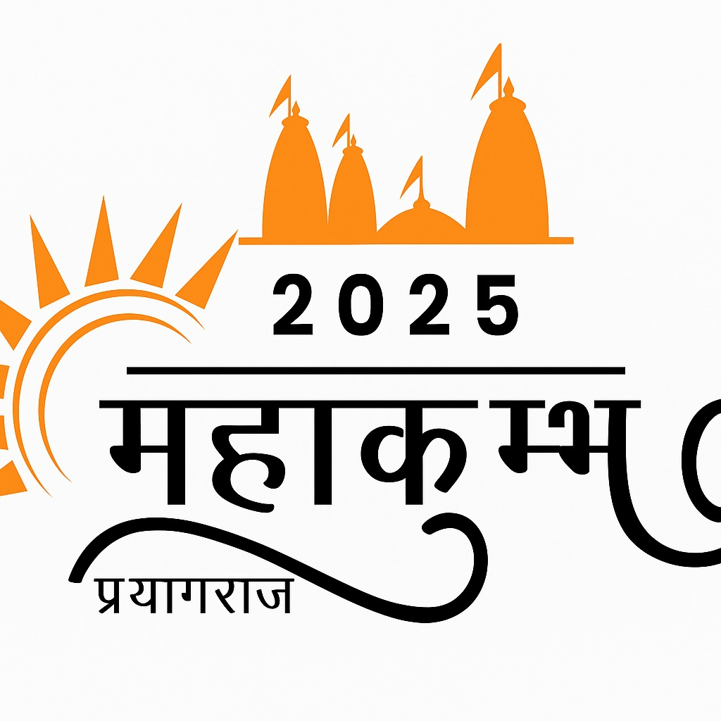

**Prepared by: Suchana Dey**

**Date: July 2025**

**Location: Prayagraj, Uttar Pradesh**

**Introduction**

The **Maha Kumbh Mela 2025** held in **Prayagraj** is one of the largest spiritual gatherings in the world, attracting millions of devotees from across India and abroad. This massive religious congregation not only showcases the country’s deep-rooted cultural traditions but also presents an enormous logistical, infrastructural, and administrative challenge for government authorities.

This report presents a **comprehensive data-driven analysis** of the journey of devotees throughout the Maha Kumbh Mela 2025. The data includes metrics on **pilgrim attendance**, **accommodation quality**, **meal distribution**, **health and safety incidents**, **Ghat preferences**, and **waste management**, among others.

By analyzing weekly trends and demographic distributions, this report aims to:

* Identify critical pressure points across time and space,
* Highlight areas of success and satisfaction,
* Pinpoint operational inefficiencies,
* And provide **evidence-based policy recommendations** to inform future planning and real-time decision-making.

The insights drawn here are intended to assist the **government, local bodies, disaster response teams, health departments, and security agencies** in improving overall coordination, resource allocation, and public service delivery during large-scale religious events.

Each section is supported by **policy-focused suggestions** to improve efficiency, preparedness, and public satisfaction.

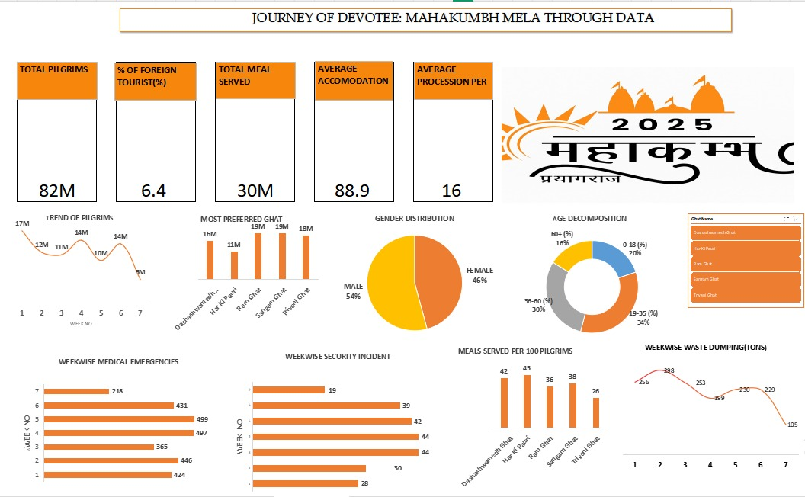

**Demographic and General Overview**

|  |  |
| --- | --- |
| Metric | Value |
| Total Pilgrims | 82 Million |
| Foreign Tourists (%) | 6.4% |
| Gender Ratio | Male: 54%, Female: 46% |
| Age Distribution | 0–18 yrs: 20%, 19–35 yrs: 34%, 36–60 yrs: 30%, 60+ yrs: 16% |

**Policy Insight**:

* A large and diverse demographic mix highlights the need for **inclusive facilities** – including child zones, elderly-friendly arrangements, and multilingual information for foreign tourists.
* Increase in foreign tourists requires **stronger international help desks, translators, and better signage** in global languages.

# **Accommodation and Meal Services**

|  |  |
| --- | --- |
| Metric | Value |
| Total Meals Served | 30 Million |
| Meals per 100 Pilgrims | Avg: 38–45 |
| Average Accommodation Rating | 88.9 / 100 |

**Policy Insight**:

* High satisfaction in accommodation indicates well-managed hospitality. This can be **standardized across all Ghats**.
* Variation in meals per 100 pilgrims suggests the **need to streamline food supply chains** and eliminate under-served areas.

# **Weekly Pilgrim Footfall**

|  |  |
| --- | --- |
| Week No | Pilgrims (Millions) |
| 1 | 17 |
| 2 | 12 |
| 3 | 11 |
| 4 | 14 |
| 5 | 10 |
| 6 | 14 |
| 7 | 5 |

**Policy Insight**:

* **Week 1 and Week 6 saw peak traffic**. Strategic deployment of security, sanitation, transport, and medical staff should be prioritized during these weeks.
* Low turnout in Week 7 suggests it could be used as a **recovery or maintenance window**.

# **Weekly Medical and Security Cases**

|  |  |  |
| --- | --- | --- |
| Week | Medical Emergencies | Security Incidents |
| 1 | 424 | 19 |
| 2 | 446 | 39 |
| 3 | 365 | 42 |
| 4 | 497 | 44 |
| 5 | 499 | 30 |
| 6 | 431 | 28 |
| 7 | 218 | 30 |

**Policy Insight**:

* Week 4 and 5 recorded **maximum medical cases**, indicating over-crowding or weather-related risks.
* Increase in security incidents during Weeks 3 and 4 signals need for **extra surveillance and rapid-response teams**.

# **Most Preferred Ghats**

|  |  |
| --- | --- |
| Ghat | Visitors (Millions) |
| Ram Ghat | 19 |
| Sangam Ghat | 19 |
| Triveni Ghat | 18 |
| Dashashwamedh Ghat | 16 |
| Har ki Pauri | 11 |

**Policy Insight**:

* **Top 3 Ghats attract over 56 million combined visitors**. These should be prioritized for crowd control systems, more toilets, and continuous cleaning cycles.
* Use **AI-driven footfall sensors** and barricade management at these Ghats.

# **Weekly Waste Dumping (in Tons)**

|  |  |
| --- | --- |
| Week | Waste Dumped (Tons) |
| 1 | 256 |
| 2 | 259 |
| 3 | 253 |
| 4 | 239 |
| 5 | 232 |
| 6 | 209 |
| 7 | 129 |

**Policy Insight**:

* Steady waste in early weeks confirms high consumption. **Need stronger cleanup protocols during Weeks 1–4.**
* Introduce **segregation bins**, composting stations, and **waste-to-energy** units.

**Key Interpretations and Policy Recommendations**

|  |  |
| --- | --- |
| Insight Area | Interpretation & Recommendation |
| Demographic Reach | Massive participation across age groups and genders demands inclusive facilities and multilingual services. |
| Accommodation | High satisfaction scores; efforts can be scaled uniformly across all zones. |
| Peak Weeks | Week 1 and 6 are most crowded. Prioritize resource deployment accordingly. |
| Health Incidents | Week 4 & 5 show medical surges. Boost emergency preparedness in those periods. |
| Security Alerts | Week 3 & 4 need higher surveillance infrastructure. |
| Waste Management | Week 1–4 show maximum dumping. Introduce stricter clean-up protocols and waste segregation systems. |
| Foreign Engagement | Foreign footfall (6.4%) can be enhanced with cultural help desks and guided facilities. |

## **Strategic Recommendations**

### **Infrastructure & Resource Allocation:**

* **Dynamic crowd control systems** during peak weeks and at top Ghats.
* **Real-time dashboards** for tracking meal supply, security alerts, and medical emergencies.
* Expand **emergency medical tents** and mobile health units in Weeks 4–5.

### **Foreign Tourist Focus:**

* Deploy multilingual signage, interpreters, and **dedicated foreign help booths**.
* Provide **guided pathways** for international devotees through apps and kiosks.

### **Sustainable Measures:**

* Implement **zero-waste goals** by enforcing biodegradable packaging.
* Install **water purification systems** at food and meal centers.

### **Technology Integration:**

* Introduce a **mobile app** for real-time Ghat crowd status, emergency contact, and service tracking.
* Deploy **drone surveillance** and **AI analytics** to anticipate high-risk zones.

**Conclusion**

Maha Kumbh Mela 2025 has seen **massive, multi-dimensional participation**. The insights suggest an urgent need to:

* Enhance crowd management protocols.
* Improve medical and security infrastructure during critical weeks.
* Prioritize waste management.
* Support foreign and elderly pilgrims.